Items from Last Report:
1. PCB Debugging: We are developing a prototype with an old PCB board. We completed the prototype after desoldering sensors and testing them.
2. Microcontroller Investigation: For the prototype we will be using an ESP32 that has 8 ADC channels
Current Issues:
1. There are no issues.
Goals for Current Week:
1. Prototype Testing: Fill the water tank and receive real-time data. Develop firmware to have a basic display of the pressure sensor data.
Short Term Goal:
1. Hardware MVP: The hardware will be able to read a signal from the pressure
sensors as a minimum viable product.
Long Term Goal:
- Sensor Signal System: The entire system will deliver a functional sensor and
decoder setup capable of outputting the clean signal required for fish wake data
analysis. July 30, 2026
Appendix
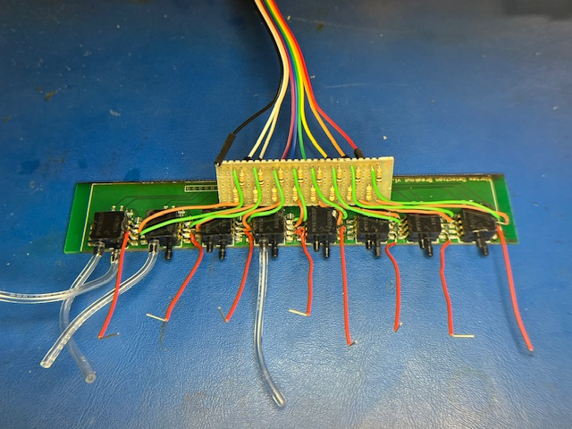
- Prototype Setup:

